Health Data Analysis

  - Ian Francis

Contents
Initial Report 2
Facility_id 2
facility_name 2
facility_type 2
capacity 2
region 2
licence_issue_date 2
inspection_date 2
gps_location 2
remarks 2

Initial Report
Overview according to python’s ydata profiling library.
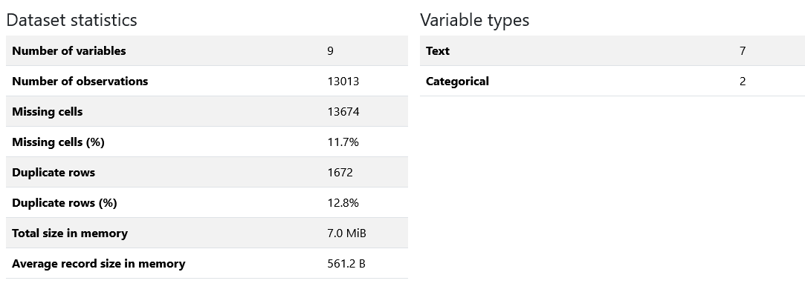
We have a lot of duplicate rows, and missing cells. First thing that was done is to remove duplicate rows.
The following is an analysis of each found data type and how they must be processed.

Facility_id
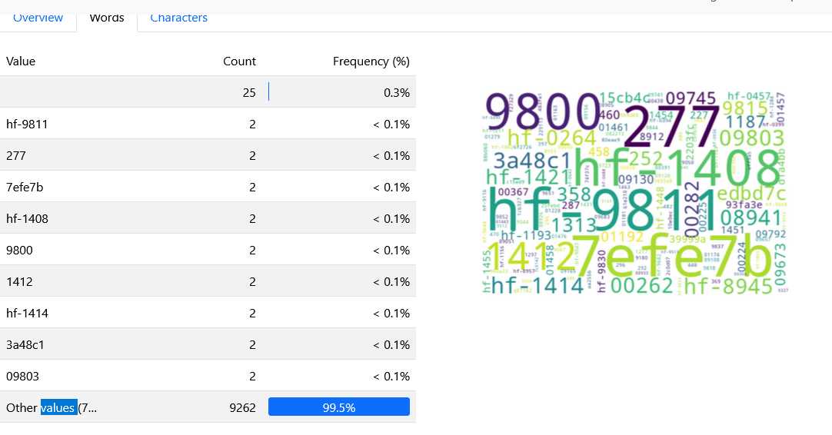
Data seems to be inconsistent. The most common format seems to be hf-XXXX where X represents a digit.

facility_name

facility_type
Many pieces of data here have abbreviated values and other inconsistent data

capacity
Many of these use words to help describe numbers. All numbers are extracted from this data.

region
Many parishes are backwards, and there are inconsistencies in the spacing of words like “Christ Church”

licence_issue_date
Most of these are written as dates but are very inconsistent in format.

inspection_date
Most of these are written as dates but are very inconsistent in format.

gps_location
Similar case with the dates, but with latitude and longitude.

remarks
Many of the texts that appear here are hearts. This likely means “Good” but is ambiguous.

